

PHINMA UNION COLLEGE OF LAGUNA
Sta. Cruz, Laguna

Implementation of a Learning Hub Library as a Subdomain of the Municipal Disaster Risk Reduction and Management Information System with Centralized Database for Luisiana, Laguna: An Approach to Enhanced Community Preparedness and Resilience

Submitted By:
Gallardo, James Izel P.

In Partial Fulfillment
of the Requirements for the Subject
ITE 317 System Integration and Architecture 2

A Research Paper Presented to
The Faculty of the PHINMA Union College
of Laguna

October 2025
Chapter 1

THE PROBLEM AND ITS BACKGROUND

INTRODUCTION
Since the mid-20th century, the global community has recognized the need for centralized knowledge platforms to better understand and respond to disasters. As a result, various websites and digital platforms have been developed to host libraries and resources focused on natural and man-made disasters. These platforms act as important repositories of knowledge, offering access to academic literature, interactive data visualizations, and tools for real-time event tracking. Maintained by international organizations, government agencies, academic institutions, and non-profit groups, these websites support research, education, and policy development related to disaster risk reduction, emergency response, and climate resilience. Their extensive collections are essential for scholars, practitioners, and decision-makers seeking evidence-based insights and best practices in disaster management.
The global recognition of centralized digital platforms as essential tools in disaster management makes the development of a localized system urgent and necessary. As discussed, web-based repositories have proven effective in improving disaster preparedness, response, and recovery. They do this by providing access to reliable information, supporting coordination, and encouraging informed decision-making. The Municipality of Luisiana, Laguna, currently faces significant barriers in its disaster risk reduction efforts. These include poor communication, scattered data sources, and limited access to timely and accurate information. These issues highlight the need for a dedicated and accessible digital solution.
The proposed system involves creating and integrating an online library with learning resources for the Municipal Disaster Risk Reduction and Management (MDRRM) in the Municipality of Luisiana, Laguna. This digital library will act as a central platform that offers organized access to educational materials, training modules, and other information related to disaster risk reduction and management (DRRM). Its goal is to help local government units, responders, educators, and community members improve their knowledge, preparedness, and response to disaster events.
By tackling issues like poor communication, scattered data, and limited access to information, the library will encourage informed decision-making, community awareness, and learning within institutions. The system will also follow global standards and best practices in disaster information management, ensuring that local stakeholders have reliable, timely, and practical knowledge. In the end, adding a dedicated online library to the MDRRMIS is an important step toward creating a more resilient, informed, and proactive community.
This digital library will empower local government units, barangay coordinators, educators, and the wider community to enhance their understanding, preparedness, and response capabilities. More than just a repository, it will serve as a dynamic tool for capacity building, and informed decision-making. Ultimately, this system lays the groundwork for a more resilient and adaptive disaster management framework in Luisiana—one that reflects a commitment to proactive governance, community engagement, and sustainable development in the face of future risks.
SYSTEM OVERVIEW
The proposed system is the Online Municipal Disaster Risk Reduction and Management Information System (MDRRMIS), designed for the Municipality of Luisiana, Laguna. This web-based platform will act as a central digital hub that combines a library of disaster-related learning resources. It aims to improve disaster preparedness, response, and recovery operations by providing organized, real-time access to important materials and information.
The system includes a structured digital library that contains educational content, training modules, and community guidelines related to Disaster Risk Reduction and Management (DRRM). These resources will be selected according to national standards and international best practices, ensuring they are relevant and useful for local contexts.
Users of the platform, including local government officials, barangay coordinators, emergency responders, educators, and community members, will benefit from a simple interface that allows for easy navigation, quick document retrieval, and on-demand learning. The platform will also have search and categorization functions, helping users find specific resources based on themes like preparedness, mitigation, response, or recovery.
Overall, the Online MDRRMIS is more than just a technological solution; it is a strategic tool for building local disaster resilience. It reflects a broader move toward digital governance in public safety and disaster management, connecting the municipality’s efforts with global trends and national development goals.

SUMMARY OF MODULES
The Online Municipal Disaster Risk Reduction and Management Library (MDRRML) consists of four main modules: Admin, Barangay Coordinator, User, and API. Each module has a specific role in managing and sharing disaster-related educational resources.
The Admin module gives full control of the system to authorized personnel. They can manage user accounts, categorize and upload content, validate information, and ensure the digital library's integrity and relevance. This module is crucial for keeping the quality and organization of learning materials, including training manuals, and other disaster-related documents.
The Barangay Coordinator module helps local engagement. It gives barangay officials access to important resources and allows them to suggest additional content that reflects their communities' unique disaster risk profiles and preparedness needs. Barangay Coordinators also has an access to uploading resources for the community.
The User module provides general access for community members, educators, students, and other stakeholders. It has a user-friendly interface that makes it easy to browse, search, and download materials. This helps promote public awareness and knowledge-sharing on disaster risk reduction.
The API module improves the system's scalability and interoperability. It enables secure connections with external platforms like municipal learning management systems, academic portals, or regional DRRM databases. This lets different institutions share resources more easily.
Together, these modules create a well-organized and functional platform. They support the municipality's goals of building disaster resilience, improving institutional preparedness, and encouraging community-based learning through a centralized digital repository.

OBJECTIVES
General Objectives
- To develop and implement a centralized, web-based library platform that provides accessible, organized, and reliable disaster risk reduction and management (DRRM) learning resources for the Municipality of Luisiana, Laguna.
Specific Objectives
- To provide local government units, barangay coordinators, educators, and community members with streamlined access to educational materials and training manuals.
- To promote public awareness and community-based disaster preparedness by disseminating localized, practical, and easy-to-understand learning content.
- To support coordination and knowledge-sharing between municipal departments and barangays through structured information management within a centralized system.
- To ensure the system’s scalability and interoperability through the development of an Application Programming Interface (API) that allows for integration with other platforms such as educational portals, municipal systems, or regional DRRM databases.
The stated goals provide a solid base for creating a digital library that addresses the disaster preparedness and educational needs of the Municipality of Luisiana. The general objective outlines the main aim of creating an accessible and centralized resource platform. The specific objectives focus on ensuring the library's functionality, inclusivity, and relevance. Together, these objectives help strengthen the municipality's disaster resilience through informed decision-making, better coordination, and active community participation.

SCOPE AND DELIMITATIONS
The proposed Online MDRRMIS is a centralized digital library that aims to provide educational materials on disaster risk reduction and management for the Municipality of Luisiana, Laguna. It includes general learning resources like training modules, infographics, and community-based instructional content. Different user roles are set for administrators, barangay coordinators, and the public. The system can also support future integration through an API.
However, the system does not include official policy documents, legislative records, or academic case studies. It is not meant for real-time disaster monitoring, emergency communication, or professional certification. The content is limited to basic educational resources relevant to the local context, with no support for advanced training or technical simulations.

SYSTEM ARCHITECTURE
The Online Municipal Disaster Risk Reduction and Management Library (MDRRML) includes four main modules: Admin, Barangay Coordinator, User, and API. The Admin module handles accounts, checks uploads, and maintains the quality of resources. The Barangay Coordinator module links local communities by providing access to materials and allowing officials to add localized content. The User module provides a simple interface for citizens, educators, and stakeholders to browse and download resources. The API module allows different systems to work together by enabling integration with external platforms and databases. These modules create a unified system that promotes disaster resilience, preparedness, and community-based learning through a centralized digital library.

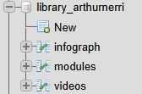
Local (Development Environment)
Figure 1. System Database for MDRRMO Library Subdomain
The figure 1 shows the local database (Xampp) to store data(s) from the system’s major operations–Training modules (Modules with Chapters), Videos (Accessible videos about disasters), and infographics (Visual representation of tips and tricks) –for the community to access and download.

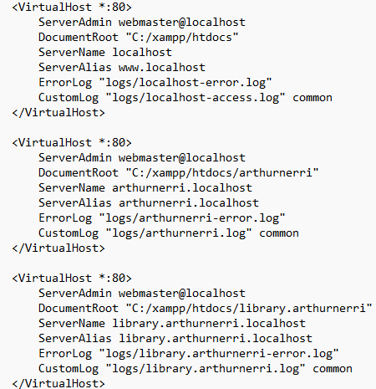

Figure 2. Apache HTTP Server Configuration for Domain and Subdomain
Figure 2 shows the local server environment, using XAMPP and Apache, where it can simulate a multi-site deployment structure. By giving specific domain access paths and document roots, it allows for the separation and controlled testing of individual systems within a single infrastructure. It ensures reliability, maintainability, and a smooth transition to a live production server.

Live (Production Server)
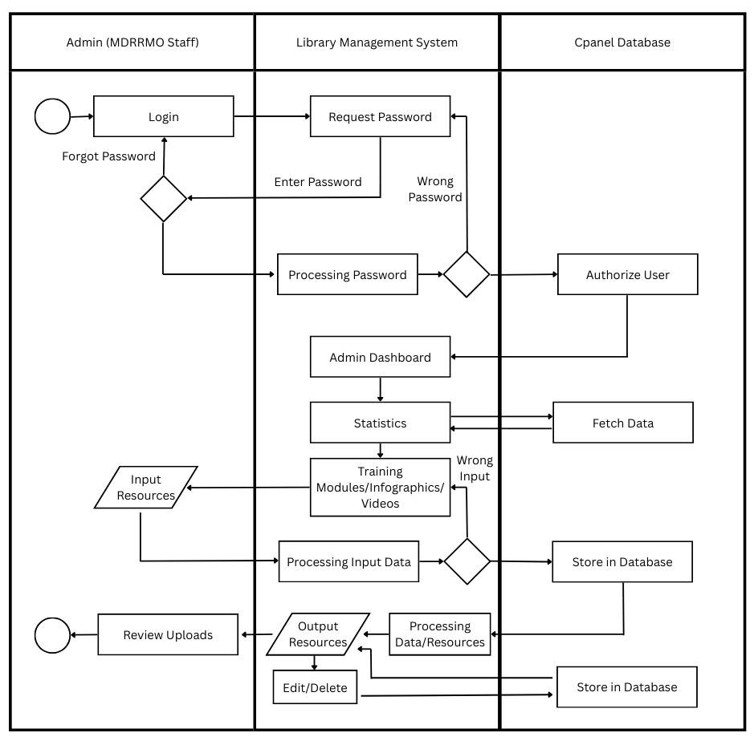
The Municipal Disaster Risk Reduction and Management Office (MDRRMO) Library system is deployed on a secure and scalable live hosting environment managed via cPanel, a widely adopted web-based control panel that simplifies server administration by enabling domain setup, email configuration, file and backup management, and database administration through a unified graphical interface (What Is CPanel? Key Features and Benefits Explained, 2024).
Figure 3. ADMIN UML Activity Diagram Using Cpanel Hosting
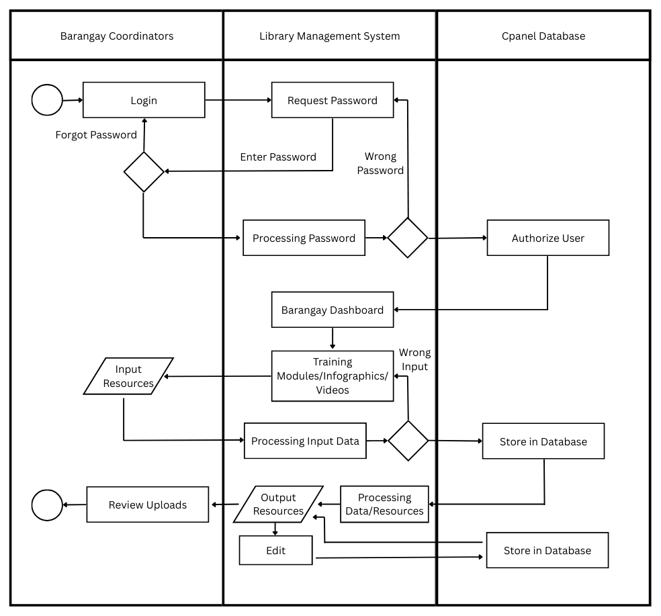
The diagram presents the workflow of a Library Management System for Admin (MDRRMO Staff), emphasizing secure access, resource management, and database integration. The process begins with user authentication through login and password validation, followed by authorization via the CPanel database. Once authenticated, users can direct to Admin Dashboard to access viewing pages for statistics, uploading training modules, infographics, and instructional videos. The system also facilitates resource input, processing, validation, storage, and retrieval, with options for editing, deletion, and reviewing uploads. Overall, the framework highlights a structured and systematic approach to ensuring secure access, efficient data handling, and effective resource management in support of admin-level educational initiatives.
Figure 4. Barangay UML Activity Diagram Using Cpanel Hosting
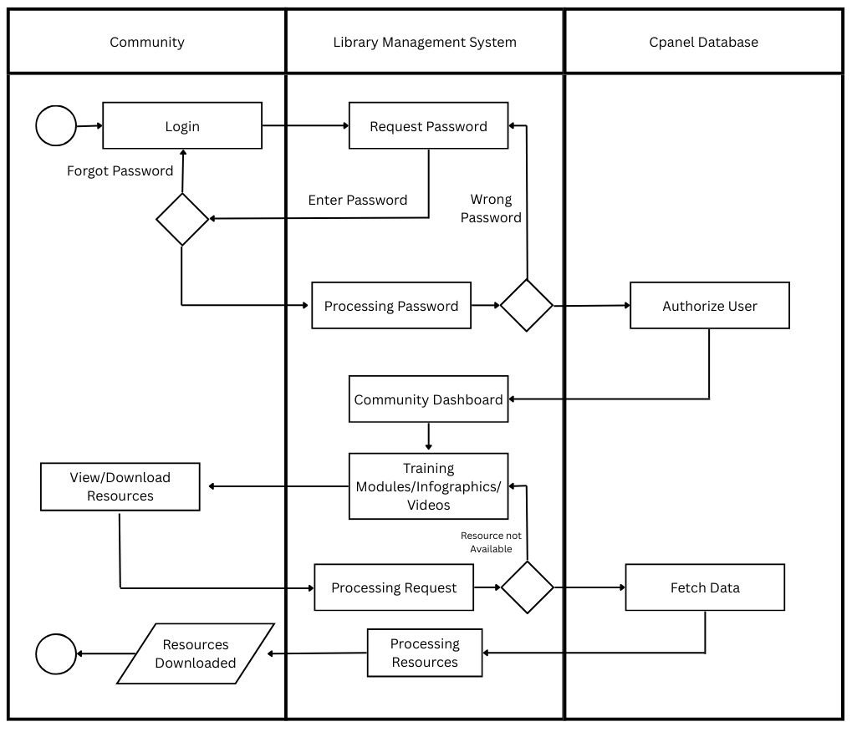
The diagram presents a structured workflow of the Library Management System for Barangay Coordinators, emphasizing secure authentication, resource management, and database integration. The process begins with user login and password validation, followed by authorization to access the Barangay Dashboard. Users can manage training modules, infographics, and videos, as well as input, process, and validate resources from the pages presented. Valid data is systematically stored in the database, while errors are redirected for correction. The system also allows editing, updating, and reviewing of uploaded resources, ensuring accuracy and reliability. Overall, the framework highlights an organized and secure approach to data handling and resource management in support of barangay-level training and educational initiatives.
Figure 5. Community UML Activity Diagram Using Cpanel Hosting
Figure 5 presents the process flow of the Library Management System for community users, highlighting authentication, resource access, and database integration. Users begin by logging in, with provisions for password recovery and error handling. Upon successful authorization, users will be directed to the Community Dashboard, where training modules, infographics, and videos’ pages can be accessed. Resource requests are processed, and if unavailable, the system retrieves data from the database to fulfill them. Once processed, resources become accessible for viewing or downloading. This framework demonstrates a secure, systematic, and efficient approach to managing community access to educational and informational resources.

SUBDOMAIN DESIGN
Subdomain | Purpose | Users | Description
arthurnerri.tech | Main Dashboard | Community, Brgy. Coordinators, Admin | Overview of DRRM on Luisiana, Laguna
systemadmin.arthurnerri.tech | Admin Panel | Admin | CRUD operations for managing users and records
report.arthurnerri.tech | User/Brgy. Coordinators Reporting | Community, Brgy. Coordinators, Admin | Report Emergencies and Community Engagement Activities
library.arthurnerri.tech | Access for Learning Materials Regarding Disasters | Community, Brgy. Coordinators, Admin | Manage uploading and deleting of Learning Materials for the community to access
inventory.arthurnerri.tech | Materials and Supplies Management | Community, Brgy. Coordinators, Admin | Manage inventory for materials, equipment, and supplies for disaster recovery and planning.
Table 1. Users, Purpose, and Subdomain Functionalities
Table 1 presents the users, purpose, and subdomain’s system functionalities. The subdomain design for arthurnerri.tech supports disaster management in Luisiana, Laguna through five key subdomains: a main dashboard for general information, an admin panel for user management, a reporting tool for emergencies, a library for learning materials, and an inventory system for managing supplies. Each subdomain serves specific users, including the community, barangay coordinators, and administrators.

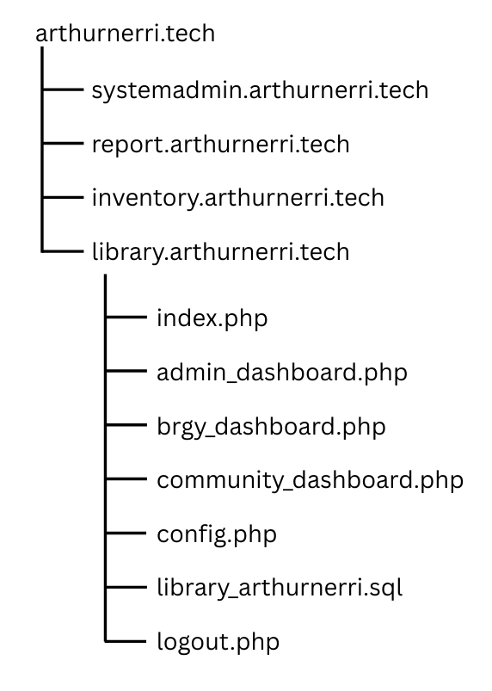
Diagram of Subdomain Structure
Figure 6. Diagram of Subdomain Structure
The subdomain library.arthurnerri.tech is the main platform for managing and accessing disaster-related learning materials within the arthurnerri.tech system. It provides role-based dashboards for administrators, barangay coordinators, and community users. This is backed by a structured database and configuration files that ensure secure session handling. This organized setup allows for efficient content delivery, effective user management, and supports community education on disaster preparedness and response.

TECHNOLOGY STACK
Frontend: HTML, CSS, JavaScript
HTML
HTML serves as the structural foundation of the Learning Library for Disaster system. It defines the content and layout of each page. It organizes text, images, forms, and multimedia resources, making sure that educational materials are displayed correctly and are accessible to different types of users. Using HTML gives the system a consistent structure that supports usability, searchability, and compatibility across various web browsers and devices.
CSS
CSS is used to control how the system looks. This helps create a user-friendly and engaging interface. Stylesheets apply elements like colors, typography, layouts, and responsive design. These improvements make the content easier to read and enhance the user experience. In disaster education, a clear and well-styled interface makes important information easy to access and visually distinct.
JavaScript
JavaScript adds interactivity and dynamic features to the Learning Library for Disaster system. It allows real-time updates, form validations, interactive dashboards, and resource filtering without the need for constant page reloads. This improvement boosts efficiency and responsiveness. This functionality is crucial for engaging users. It helps administrators, coordinators, and community members navigate, search, and interact with learning materials easily.
Backend: PHP
PHP
PHP is the backend of the Learning Library for Disaster system. It manages dynamic content, user authentication, and database operations. Its integration with MySQL provides reliable storage and retrieval of learning materials. Features like session handling and input validation add security. PHP is widely supported by hosting platforms like cPanel. It offers a practical and cost-effective way to deploy and maintain the system.
Database: MySQL
MySQL is a great choice for the Learning Library for Disaster system because it manages structured data effectively. This data includes user accounts, training modules, and learning resources. It provides strong security features like authentication, access control, and data integrity. These features are crucial for protecting disaster-related information. Its easy integration with PHP and cPanel hosting also makes it a practical, scalable, and budget-friendly database solution.
Hosting: XAMPP (local), cPanel (live)
Xampp
XAMPP is used as the local hosting environment because it provides an all-in-one package of Apache, MySQL, and PHP, allowing developers to easily replicate the production setup. Its simple installation and control panel make managing services efficient for testing and debugging. Being open-source and cross-platform, it is also a cost-effective solution for system development.
cPanel
cPanel is used for live hosting because it provides a secure and user-friendly platform for managing domains, files, databases, and SSL certificates. It simplifies deployment and maintenance through built-in tools for backups and monitoring, making it a practical and cost-effective solution for long-term system hosting.
Tools: Visual Studio Code, phpMyAdmin
Visual Studio Code
Visual Studio Code (VS Code) is used as the development tool because it supports multiple languages like HTML, CSS, JavaScript, and PHP while providing features such as syntax highlighting, debugging, and version control integration. Its wide range of extensions, customization options, and cross-platform availability make it a practical and efficient tool for building the system.
phpMyAdmin
phpMyAdmin is used in the system as a web-based interface for managing the MySQL database, simplifying tasks such as creating tables, executing queries, and handling user privileges. It enhances efficiency and usability, making database administration more accessible and maintainable for the Learning Library for Disaster system.

DATABASE DESIGN
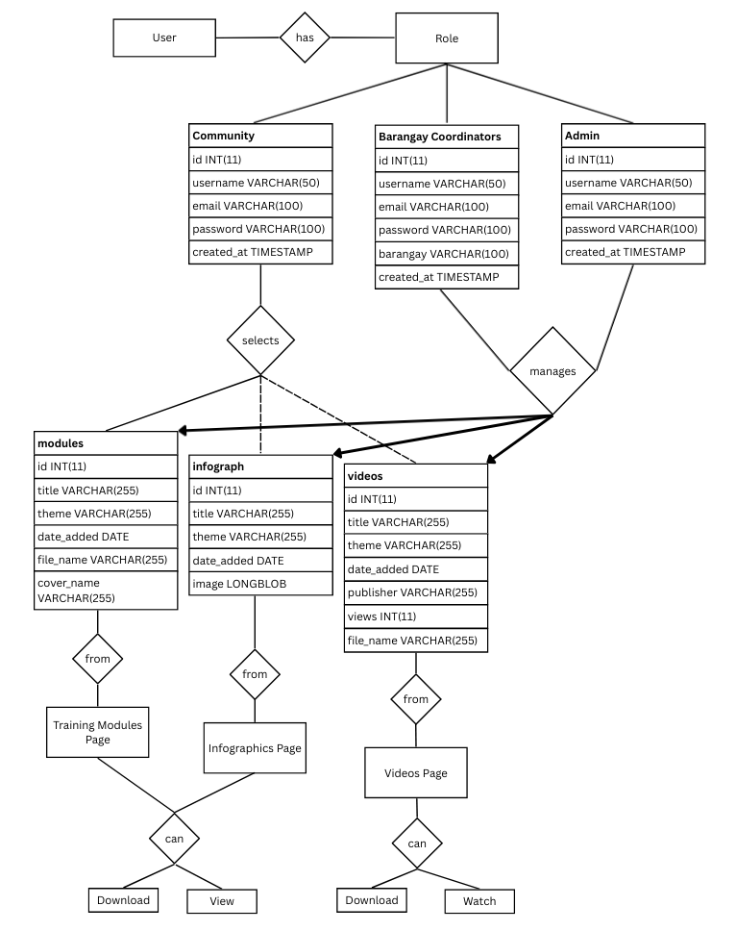
ER Diagram
Figure 7. Entity Relationship Diagram of MDRRM Library System
The ER diagram represents the structure of the MDRRM Library system, which manages disaster preparedness resources for different user roles: Admins, Barangay Coordinators, and Community members. Admins manage training modules, infographics, and videos, while users can access these materials through dedicated pages. The system enforces role-based access and supports actions like downloading, viewing, and watching content, ensuring efficient and organized dissemination of disaster risk reduction information.

Description of Database Tables
Field | Data Type | Description
id | INT (11) | Unique identifier for each infographics
title | VARCHAR (255) | Name of infographics
theme | VARCHAR (255) | Category of infographics
date_added | DATE | Timestamp when the infographics was posted
image | LONGBLOB | Stores the binary data of uploaded images
Table 2. System’s Database Table for Infographics

Field | Data Type | Description
id | INT (11) | Unique identifier for each modules
title | VARCHAR (255) | Name of module
theme | VARCHAR (255) | Category of module
date_added | DATE | Timestamp when the module was posted
file_name | VARCHAR (255) | Name of the file to be posted
cover_name | VARCHAR (255) | Name of the file for module’s image cover
Table 3. System’s Database Table for Modules

Field | Data Type | Description
id | INT (11) | Unique identifier for each videos
title | VARCHAR (255) | Name of video
theme | VARCHAR (255) | Category of video
date_added | DATE | Timestamp when the video was posted
publisher | VARCHAR (255) | Name of the publisher
views | INT (11) | Number of views on video
file_name | VARCHAR (255) | Name of the file to be posted
Table 4. System’s Database Table for Videos

SQL Code
-- phpMyAdmin SQL Dump
-- version 5.2.1
-- https://www.phpmyadmin.net/
--
-- Host: 127.0.0.1
-- Generation Time: Aug 28, 2025 at 10:39 AM
-- Server version: 10.4.32-MariaDB
-- PHP Version: 8.2.12

SET SQL_MODE = "NO_AUTO_VALUE_ON_ZERO";
START TRANSACTION;
SET time_zone = "+00:00";

/*!40101 SET @OLD_CHARACTER_SET_CLIENT=@@CHARACTER_SET_CLIENT */;
/*!40101 SET @OLD_CHARACTER_SET_RESULTS=@@CHARACTER_SET_RESULTS */;
/*!40101 SET @OLD_COLLATION_CONNECTION=@@COLLATION_CONNECTION */;
/*!40101 SET NAMES utf8mb4 */;

--
-- Database: `library_arthurnerri`
--
--
-- Table structure for table `infograph`
--

CREATE TABLE `infograph` (
`id` int(11) NOT NULL,
`title` varchar(255) NOT NULL,
`theme` varchar(255) NOT NULL,
`date_added` date NOT NULL,
`image` longblob NOT NULL
) ENGINE=InnoDB DEFAULT CHARSET=utf8mb4 COLLATE=utf8mb4_general_ci;

--
-- Table structure for table `modules`
--

CREATE TABLE `modules` (
`id` int(11) NOT NULL,
`title` varchar(255) NOT NULL,
`theme` varchar(255) NOT NULL,
`date_added` date NOT NULL,
`file_name` varchar(255) NOT NULL,
`cover_name` varchar(255) NOT NULL
) ENGINE=InnoDB DEFAULT CHARSET=utf8mb4 COLLATE=utf8mb4_general_ci;

--
-- Table structure for table `videos`
--

CREATE TABLE `videos` (
`id` int(11) NOT NULL,
`title` varchar(255) NOT NULL,
`theme` varchar(255) NOT NULL,
`date_added` date NOT NULL,
`publisher` varchar(255) NOT NULL,
`views` int(11) DEFAULT 0,
`file_name` varchar(255) NOT NULL
) ENGINE=InnoDB DEFAULT CHARSET=utf8mb4 COLLATE=utf8mb4_general_ci;
--
-- Indexes for dumped tables
--
--
-- Indexes for table `infograph`
--
ALTER TABLE `infograph`
ADD PRIMARY KEY (`id`);
--
-- Indexes for table `modules`
--
ALTER TABLE `modules`
ADD PRIMARY KEY (`id`);
--
-- Indexes for table `videos`
--
ALTER TABLE `videos`
ADD PRIMARY KEY (`id`);
--
-- AUTO_INCREMENT for dumped tables
--
--
-- AUTO_INCREMENT for table `infograph`
--
ALTER TABLE `infograph`
MODIFY `id` int(11) NOT NULL AUTO_INCREMENT, AUTO_INCREMENT=4;
--
-- AUTO_INCREMENT for table `modules`
--
ALTER TABLE `modules`
MODIFY `id` int(11) NOT NULL AUTO_INCREMENT, AUTO_INCREMENT=9;
--
-- AUTO_INCREMENT for table `videos`
--
ALTER TABLE `videos`
MODIFY `id` int(11) NOT NULL AUTO_INCREMENT, AUTO_INCREMENT=7;
COMMIT;

/*!40101 SET CHARACTER_SET_CLIENT=@OLD_CHARACTER_SET_CLIENT */;
/*!40101 SET CHARACTER_SET_RESULTS=@OLD_CHARACTER_SET_RESULTS */;
/*!40101 SET COLLATION_CONNECTION=@OLD_COLLATION_CONNECTION */;

